**ExpaTeach Website Change**

1. Please completely delete Profile pg. 3 and pg. 4

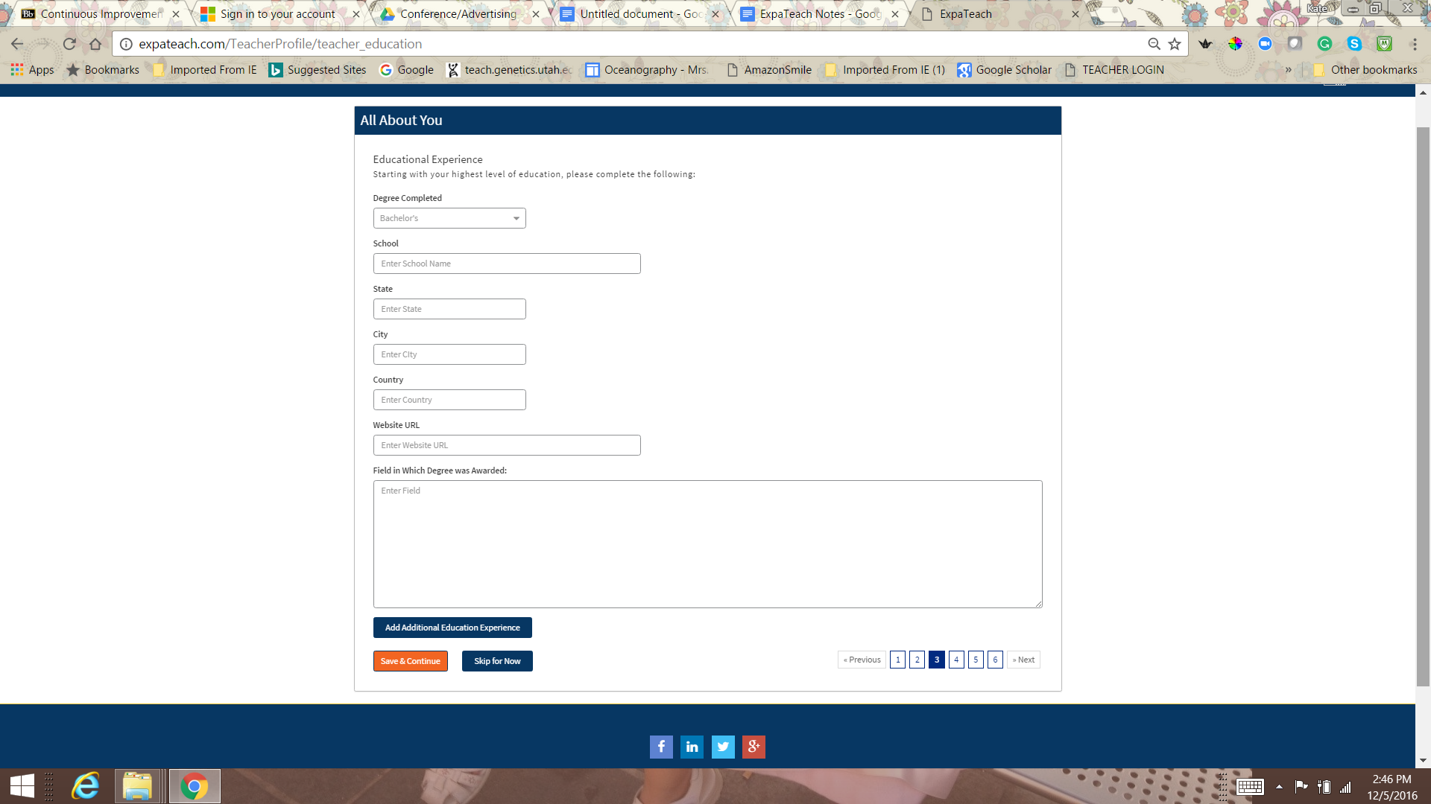

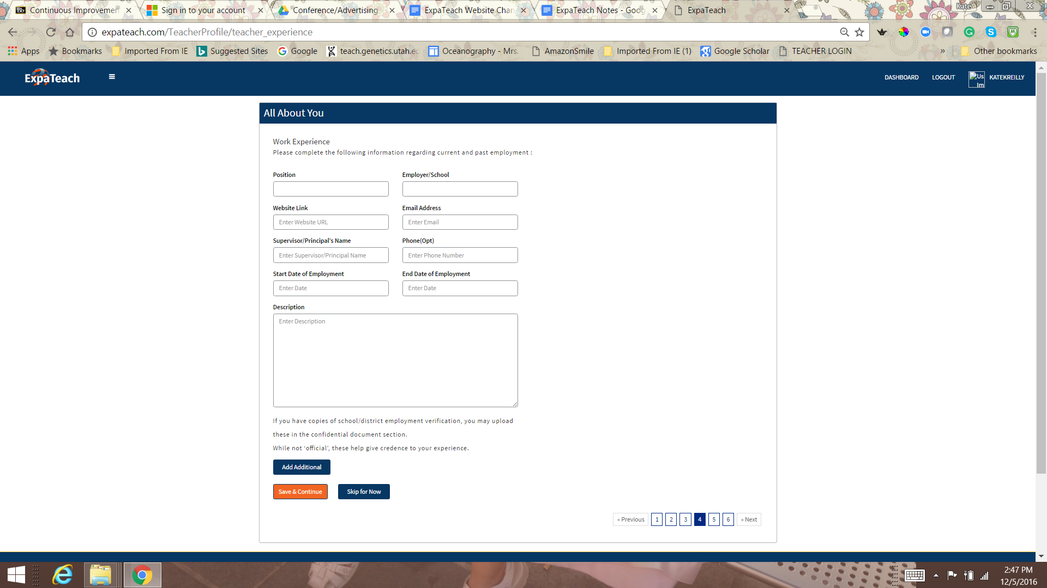

2. Change the DOCUMENT UPLOADS page--

NEW-- add word “(optional)” and then “Résumé and Other”

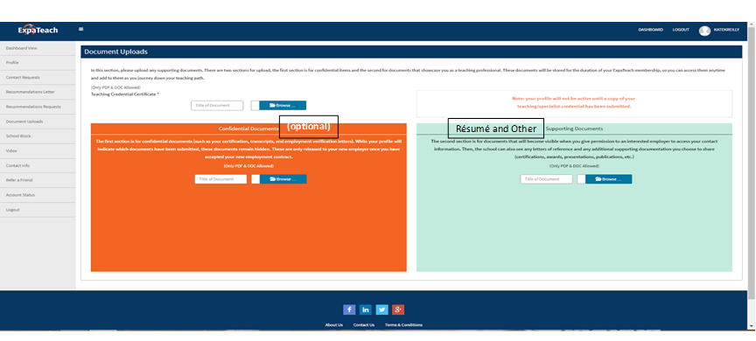

3 On the Q/A page, it will only save if all answers are complete. Please change so that it saves whatever is added, **leaving blank answer are okay**. Let them pick and choose. And to be clear, add this **(*(Answer any questions you choose, you do not have to answer all).*at the top**after—

#### ***Getting to Know You***

***Please be descriptive, but keep your answers succinct so that your responses have a better chance of being read. (Answer any questions you choose, you do not have to answer all).***

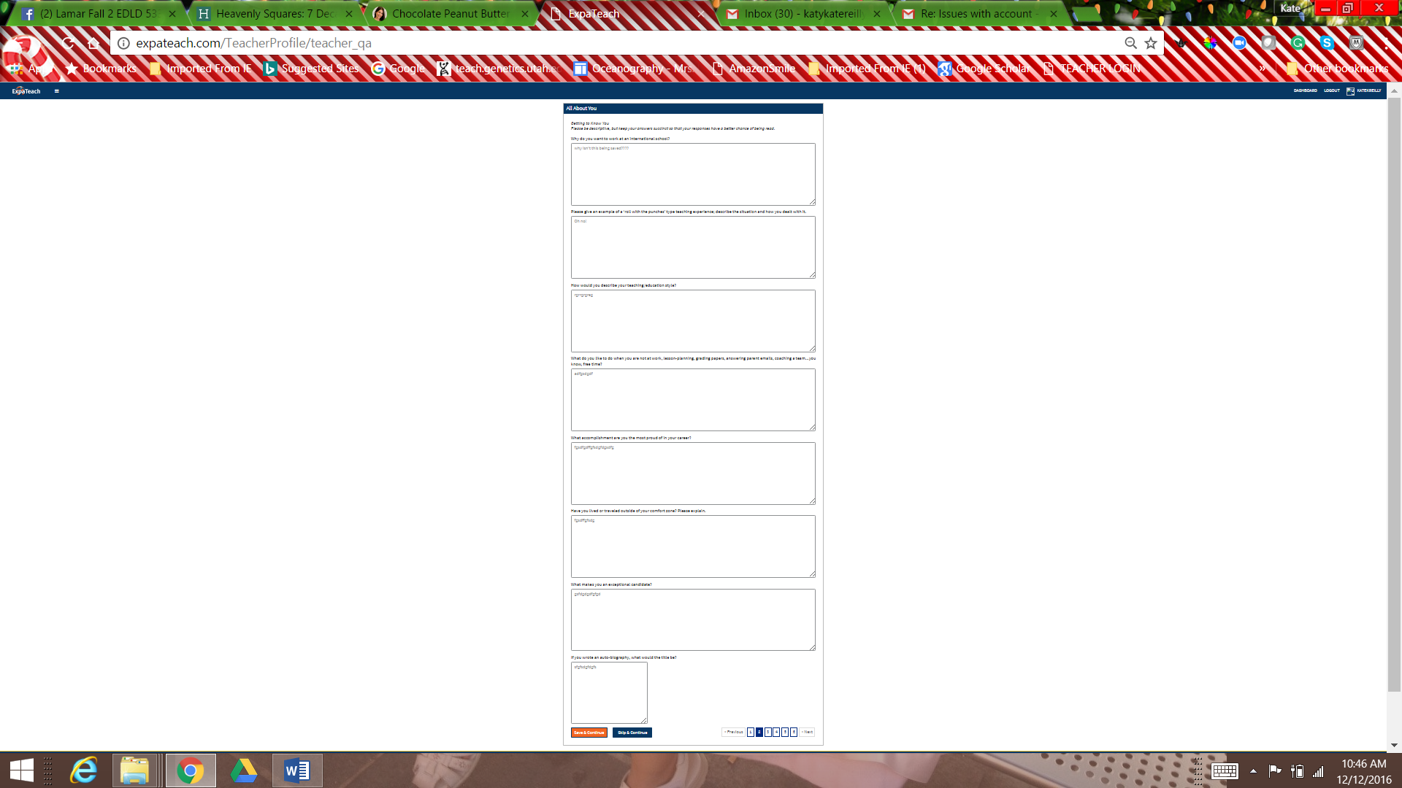

(3. Please provide time quote for the following only-- On the admin website page, please allow for multiple “verify profile” checkboxes to be checked at one time instead of individually.)

Thank You,

Kate Reilly